Title |  | 77-604-0800730-01 _Assy.Stepper Motor Driver Module,Siemens PLC,AWI

Document Change & History Record

Version | Major Change | Initiator | DCN No. | Effective Date
A | First Release | Sheng Wang |  | yyyy/mm/dd

Content

1 SCOPE 範圍 4
2 REQUIRED TOOL and SKILL需求工具 與技能 4
2.1 Tool and Equipment工具與設備 4
2.2 Qualification and Skill 作業資格與技能 4
3 COMPLETE ASSEMBLY MATERIAL 料件需求 4
3.1 PCBA section, refer to 77-618-0800731-01 BOM 4
3.2 Schematic section, refer to 77-017-0800731-01.pdf 4
3.3 PCB Gerber section, refer to 77-018-0800731-01.pcb 4
3.4 FW: 77-022-1201001-00, V100 4
4 ASSEMBLY PROCEDURE 製作過程 4
4.1 PCB Clean and Baking (MMF3-015) 4
4.2 PCBA assembly 4
4.3 Outward (VISUAL) 6
4.4 Module assembly 6
5 TESTED TOOL and EQUIPMENT檢驗工具與設備 6
5.1 DC Power +24V 6
5.2 Step motor 6
5.3 Flat screwdriver 6
6 TESTED PROCEDURE檢驗步驟 7
6.1 Firmware download 7
6.2 Function Check 7
7 EHS NOTICE 環安衛注意事項 8
7.1 可能造成環境衝擊面 8
7.2 可能造成的危害 8
7.3 危害防範措施 8

SCOPE 範圍

This document applies to manufacturing PN : 77-604-0800730-01

■Assembly ■Bench Test □System Test

REQUIRED TOOL and SKILL需求工具 與技能

In this paragraph, the owner of AWI should consider required tools and skills in the following sections.

Tool and Equipment工具與設備

Multimeter x1

2.1.2 Soldering Iron x1

Electrostatic Ring x1

Qualification and Skill 作業資格與技能

Production or testing personnel could be follow and study by AWI procedure with electrical background. For technical skill, pls ask related engineer.

COMPLETE ASSEMBLY MATERIAL 料件需求

PCBA section, refer to 77-618-0800731-01 BOM

Schematic section, refer to 77-017-0800731-01.pdf

PCB Gerber section, refer to 77-018-0800731-01.pcb

FW: 77-022-1201001-00, V100

ASSEMBLY PROCEDURE 製作過程

PCB Clean and Baking (MMF3-015)

PCB alcohol soak about 2 hour then clean

PCB oven-aging bakes 60 degree about 8 hour for heat-resistant checking

PCBA assembly

Install IC power driver L298HN on U3,U4,U5 and regulator +5v on U6 solder with metal bar step by step

Assembly some of ME parts (Bottom foundation)
- 77-130-0323501-00 , Bottom plate
- 77-151-0300005-00 , EXTRUTION BAR D FOR STEPING MOTOR
- 77-110-0344701-00 , Headsink.Step Motor Driver Box
- 77-160-0000202-00 , Threaded Hex Spacer, FF,

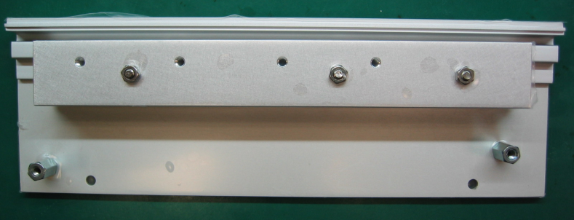
1
2
3
4
4

Headsink backside stick High Temp Tape Kapton
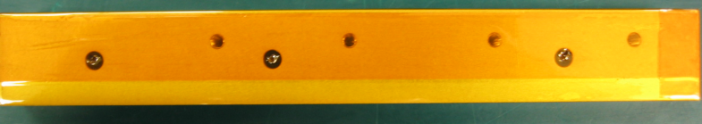

CAUTION ：Please pay attention for the Metal bar and PCB leveling with bottom base during soldering and avoid the PCB and extrution bar C stacking then solder U3, U4, U5, U6 as(Fig-1)
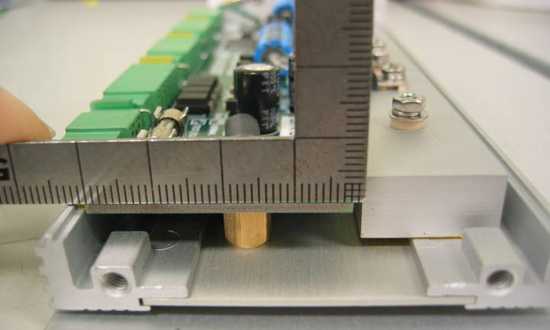

Leveling

(Fig-1)

U3
U4
U5
U6
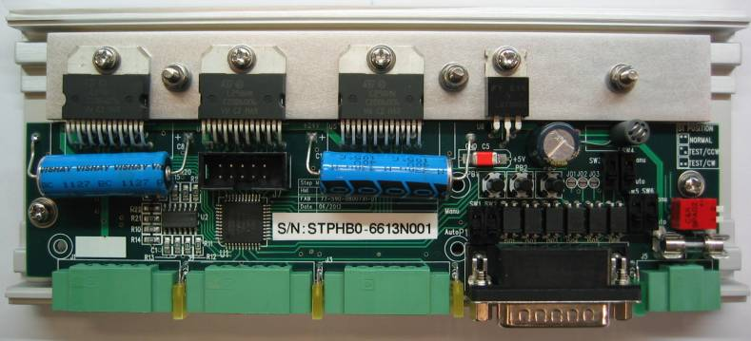

Outward (VISUAL)

Whether checking surface has a scoring, dirty, material shortage and word printed clear or not

Module assembly

Base on 77-607-0800730-00 stepper motor box drawing and stick label as below
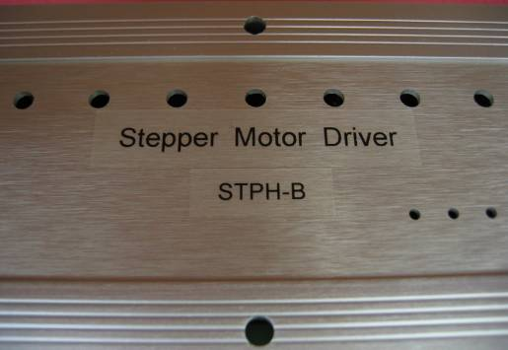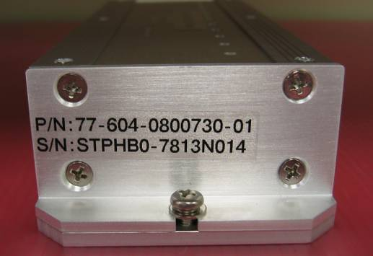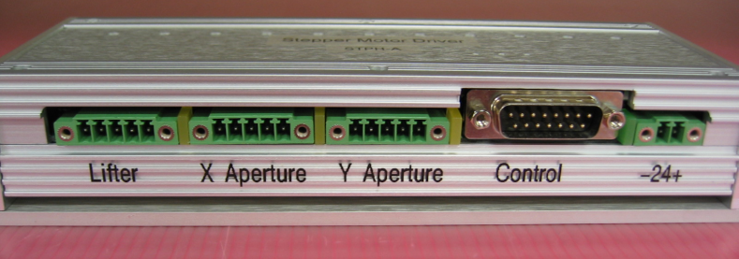
Note operation direction front side

TESTED TOOL and EQUIPMENT檢驗工具與設備
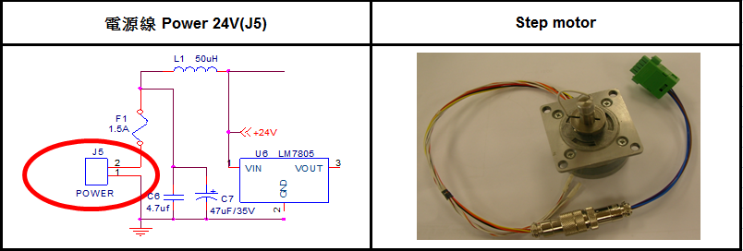

DC Power +24V

Step motor

Flat screwdriver

TESTED PROCEDURE檢驗步驟

Firmware download

Apply +24V on J5,FW download P/N:77-022-1201001-00 STPD,3 DIR,V100.pof”by Quartus II

Function Check

Stepper motor motion check by push bottom (SETTING ON MANUAL MODE) (Fig-2) and SW1, SW2, SW3, SW4, SW5, SW6 change to Manu site
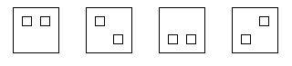
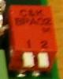
Normal Test CW Test CCW Invalid

Dip Switch Auto/Manual select
*撰寫字體: 中文細明體12 ;英文Times New Roman 12
*日期格式以月/日/年。Ex: 03/28/04
*標題格式以阿拉伯數字為主：第一層為 1， 第二層為 1.1，第三層為 1.1.1依此類推，表格、圖表、圖像則不在此限。
*修改的部分需以紅字撰寫以方便識別。
*引述文件及其編號則依大括號含小括號

文件內容的撰寫格式
*撰寫字體: 中文細明體12 ;英文Times New Roman 12
*日期格式以月/日/年。Ex: 03/28/04
*標題格式以阿拉伯數字為主：第一層為 1， 第二層為 1.1，第三層為 1.1.1依此類推，表格、圖表、圖像則不在此限。
*修改的部分需以紅字撰寫以方便識別。
*引述文件及其編號則依大括號含小括號。Ex[文件封面格式]（MDC4-001）

001

文件內容的撰寫格式
*撰寫字體: 中文細明體12 ;英文Times New Roman 12
*日期格式以月/日/年。Ex: 03/28/04
*標題格式以阿拉伯數字為主：第一層為 1， 第二層為 1.1，第三層為 1.1.1依此類推，表格、圖表、圖像則不在此限。
*修改的部分需以紅字撰寫以方便識別。
*引述文件及其編號則依大括號含小括號

文件內容的撰寫格式
*撰寫字體: 中文細明體12 ;英文Times New Roman 12
*日期格式以月/日/年。Ex: 03/28/04
*標題格式以阿拉伯數字為主：第一層為 1， 第二層為 1.1，第三層為 1.1.1依此類推，表格、圖表、圖像則不在此限。
*修改的部分需以紅字撰寫以方便識別。
*引述文件及其編號則依大括號含小括號。Ex[文件封面格式]（MDC4-001）

001

(Fig-2)

Apply +24V on J5, standby current about 0.07A±0.02A without load,check power green led on by visual then record the result in the TIPQC-000106 doc. item【1】。

Set Dip switch set on Test CW direction then check each channel status

If step motor connect to output Lifter(J1),press PB1 and examine motor turn smoothly & yellowed on then the result in the TIPQC-000106 doc. item【2-1】。

If step motor connect to output X Aperture(J2),press PB2 and examine motor turn smoothly & yellowed on then the result in the TIPQC-000106 doc. item【2-2】。

If step motor connect to output Y Aperture(J3),press PB3 and examine motor turn smoothly & yellowed on then the result in the TIPQC-000106 doc. item【2-3】。

Set Dip switch set Test CCW direction then check each channel status

If step motor connect to output Lifter(J1),press PB1 and examine motor turn smoothly & yellowed on then the result in the TIPQC-000106 doc. item【3-1】。

If step motor connect to output X Aperture(J2),press PB2 and examine motor turn smoothly & yellowed on then the result in the TIPQC-000106 doc. item【3-2】。

If step motor connect to output Y Aperture(J3),press PB3 and examine motor turn smoothly & yellowed on then the result in the TIPQC-000106 doc. item【3-3】。

Set Dip switch set Invalid direction then check each channel status

If step motor connect to output Lifter(J1),press PB1 and examine motor without turning then record the result in the TIPQC-000106 doc. item【4-1】。

If step motor connect to X Aperture(J2),press PB2 and examine motor without turning then record the result in the TIPQC-000106 doc. item【4-2】。

If step motor connect to Y Aperture(J3),press PB3 and examine motor without turning then record the result in the TIPQC-000106 doc. item【4-3】。

If test done by manual mode,set on normal direction then record the result in the TIPQC-000106 doc. item【5】。

Record FW P/N of 77-604-0800730-01 in the TIPQC-000106 doc. item【6-1】。

Record FW version of 77-604-0800730-01 in the TIPQC-000106 doc. item【6-2】。

EHS NOTICE 環安衛注意事項

可能造成環境衝擊面
空氣污染 | ■焊鍚廢氣 ■烤箱熱氣 □其它___
水污染 | □廢水 □其它___
廢棄物污染 | □廢電線 ■廢PCB板 ■廢金屬 □廢油 ■廢溶劑 □其它____
能源 | ■電力 □其它___

可能造成的危害
物理性危害 | ■跌墜落 ■擦、刺、扭、壓、夾、碰撞、割傷  □物體飛落 ■異物入眼 □與高/低溫接觸 □噪音/震動  ■感電
化學性危害 | □化學物燒灼傷 ■化學物吸入
其它危害 | _________________________

危害防範措施
防護具 | □安全帽 □安全鞋 □安全眼鏡 □耳塞 ■手套 ■防塵口罩
 | □防毒面罩 □防化學圍裙 □防護衣 □其它____
工程控制 | ■局部排氣 □其它____
管理措施 | ■遵循工作守則 ■遵循作業指導書

